fNIRS Retinopy

Matlab Case Study for Signals and Systems (Draft)

Functional Near-Infrared Spectroscopy is an imaging method capable of measuring levels of hemoglobin in various parts of the brain to detect areas of increased blood flow. Similar to other methods of brain imaging, fNIRS can be used to detect correlations between external stimuli and increased brain activity.

In this case study, you will use a variety of data manipulation techniques to examine the results of an experimental trial using fNIRS retinopy to map the brain’s response to a rotating image. You will then use least-squares regression to estimate the phase of the image at a particular moment based on a snapshot of the brain at that same moment.

# Experimental Setup

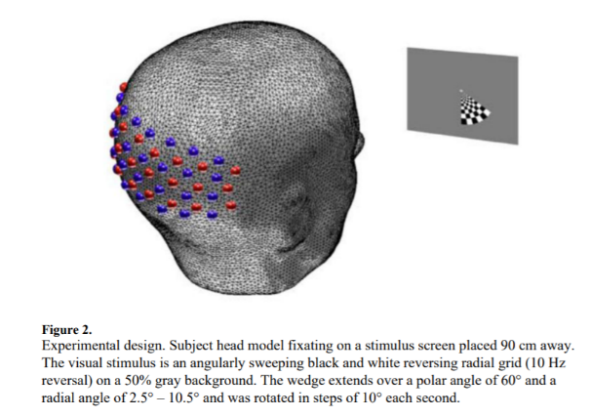In this experiment, a subject views a checkerboard wedge that slowly rotates on the screen, completing one rotation every 36 seconds (about 0.028 Hz). Meanwhile, infrared sensors measure brain oxygenation to see which spatial regions of the brain are active as the wedge moves.

Each sensor reading

# Data Structure

The results of the experiment are stored in a sophisticated data structure, stored in the Matlab workspace file, ‘NeuroDOT_Data_Sample_CCW1.mat’. The following variables are included in the workspace:

* data, a 1344x4857 matrix that contains the raw measurements for each source-detector pair. Each row corresponds to one source-detector pair. The columns represent different samples taken at different times.
* info, a structure containing several sub-structures, each with useful information:
  + optodes, a structure containing the positions, in both 2d and 3d space, of each source and each detector
  + pairs, a structure containing information for each row of data. It records which source-detector pair created the data, how far apart in both 2d and 3d space they are, and the number of nearest neighbors.
  + paradigm, <thing here>
  + system, a structure containing the sample frequency at which the measurements were made
* flags, a structure containing additional parameters you will not need to make use of

# Case Study

Open the *fNIRSCaseStudy.m* script in MATLAB and read through it, then run it. Examine the plots produced.

* The Data Traces plot overlays the signal from every sensor pair on a log scale. What do you notice about signals with a smaller amplitude? What about signals with a larger amplitude? Do you see any signals with a low frequency oscillation in them? Where do those signals appear on the data trace?
* The LFO plot shows the average amplitude of the signal from each sensor pair. The x-axis represents the distance each signal penetrates before reaching the receiver. The most useful sensor data will be from sensors that have passed through enough of the brain to measure hemoglobin content, but not so much that the desired signal has been attenuated enough to be crowded out by noise. Based on the LFO plot, what range of distance do you think will be most useful for this purpose? Record your observations in your writeup.
* The Log-Ratio Signals shows each signal pair over time, with intensity mapped to color. You should see some periodic behavior on this plot. What frequency is it? What other behavior do you observe?
* Consider the experimental setup. How might we use a highpass or lowpass filter to clean up this data? Examine the highpass() and lowpass() functions included in the case study and use them to generate a new version of the Log-Ratio Signals plot that better displays the desired periodic signal.
* Once you’ve chosen a reasonable subset of the detector data and filtered it to your liking, plot the magnitudes of the resulting Fourier transform. To prevent overplotting, you may want to only plot a few representative signals from the data. Make some observations: where are there spikes or high amplitude components? Are some signals noisier than others? Can you spot the stimulus frequency in the data?
* Examine the Source-Detector map. This map shows all of the infrared sources and detectors and marks the halfway point between each pair that we are considering in our data. Our goal is to get an “image” of the brain
* Examine the 3-d Phase map. This plot computes the phase of the Fourier transform at the stimulus frequency. E